Cargo handling without exhaust emissions or noise
LAWECO CARGO MASTER – GREEN LINE
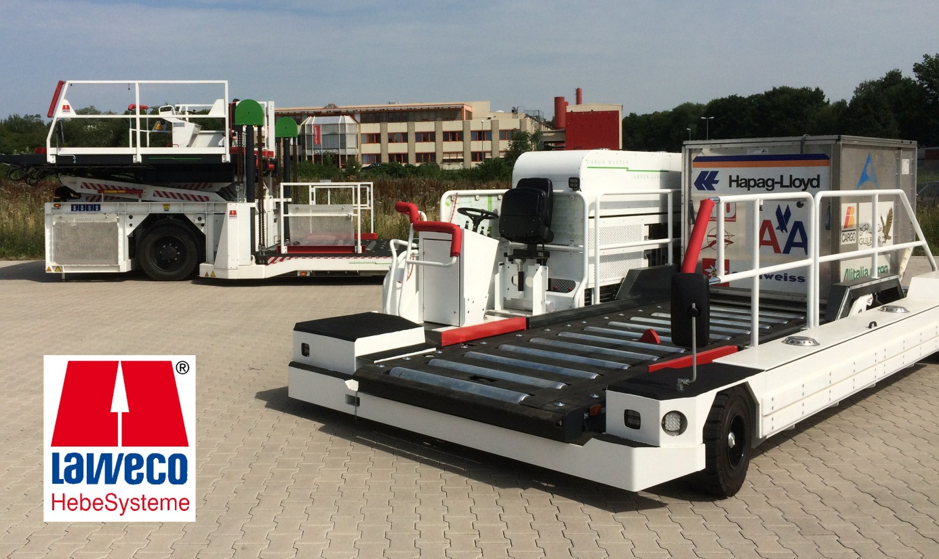
Although the aircraft ground handling equipment from LAWECO weighs several tonnes, it can be moved without exhaust emissions or noise. The electrically powered cargo handling vehicles of the CARGO MASTER – GREEN LINE series, developed from the proven diesel powered vehicles, have been continuously further developed since their market launch in 2011. All variants of the 7 tonne twin platform loader CML 7 – 3.7 are now available as a battery-powered "GREEN LINE" version. In addition, LAWECO now also uses the familiar and reliable technology in its CMLT 3.7-3.6 lifting transporter.

Airports throughout the world are making efforts to drastically reduce their carbon dioxide and noise emissions. Although ground traffic produces only a small proportion of these emissions, investment is also being made in environmentally friendly drive solutions in this area. The electrically powered vehicles from LAWECO demonstrate that the use of CARGO MASTER – GREEN LINE equipment avoids emissions and considerably cuts operating costs thanks to the efficient electric drives. A further positive effect is that it substantially improves the working conditions for the cargo staff.
The CARGO MASTER CML 7 – GREEN LINE is already used for handling the cargo of large aircraft. The vehicles move loads weighing up to 7 tonnes easily and reliably. As a result of the huge interest in its products and the problem-free use of the electrical components, LAWECO decided to use the same technology in a smaller vehicle, the CMLT 3.7-3.6.
It was necessary to overcome problems such as the considerably smaller space available and the additional weight of the battery. The vehicle already has a dead weight of 8 tonnes without the battery.
A further reason for the development of the GREEN LINE version is that it is becoming increasingly difficult to integrate the necessary exhaust components such as diesel particulate filters into the vehicles in order to meet the more stringent exhaust emission regulations in the future. Due to the intermittent operation of the vehicles these filters have a shortened service life and cause frequent engine malfunctions. Additional time at the repair shop for necessary maintenance or repairs increases the operating costs considerably.
The lifting transporter CMLT 3.7-3.6 is predominantly used for loading and unloading freight containers for aircraft such as the Airbus A319 / A320 or Boeing B767. The containers and pallets are unloaded from the hold from a height of up to 3.6 m. The CMLT has a lift platform for accommodating two containers or pallets with a maximum total weight of 3.7 tonnes. Unlike the twin platform loaders that transfer the cargo to special transporters, the CMLT moves back and forth with the freight between the aircraft and cargo dollies. As the transporter has to be repositioned next to the aircraft after each transport, sensitive control of the travel drive is particularly important. The combination of electric motors, pumps and hydraulic travel motors allows smooth and reliable docking. The hydraulic braking by rotational speed reduction is sufficient for precisely stopping the vehicle. A service brake is of course provided for safety. The freight is conveyed by hydraulically driven wide transport rollers.
The mechanical design is very similar to the diesel variant as the requirement of having to fit the A319 was the same. The most obvious difference is the battery box mounted on the motor compartment, which also accommodates the on-board charger. The 80V battery cells have a total capacity of 300 Ah. Hoppecke FNC-T batteries with low temperature tolerance and high recharge efficiency are used. The batteries can be fully charged in 30 – 45 minutes.

The two Linde electrical drive motors have a rating of 25 kW each. They are controlled via the vehicle CANbus control system. The coupled Linde hydraulic pumps provide sufficient power for the travel drive and the freight functions. As the travel drive requires the most energy, the driving speed is limited to 15 km/h for energy efficiency. Experience has shown that this speed is sufficient for the short transport paths between the aircraft and the cargo dollies. All freight functions and lifting or lowering of the platform are identical to those of the diesel transporter. Thanks to intelligent motor management in conjunction with the transporter control system, energy is needed only when a function – freight or travel – is selected. If no function is selected, the electric motors remain at a standstill.

The CMLT 3.7-3.6 GREEN LINE is the first electrically powered lifting transporter. This innovation from LAWECO will be presented at the most important trade fair for the airport industry, the Inter Airport Europe in Munich, at the LAWECO stand C46 in the Outdoor Area. LAWECO is convinced that that the GREEN LINE products from LAWECO precisely meet the requirements of cargo handlers: emission-free, economical, reliable and fast.

